History of
Anglesey Abbey
and
Life of Lord Fairhaven

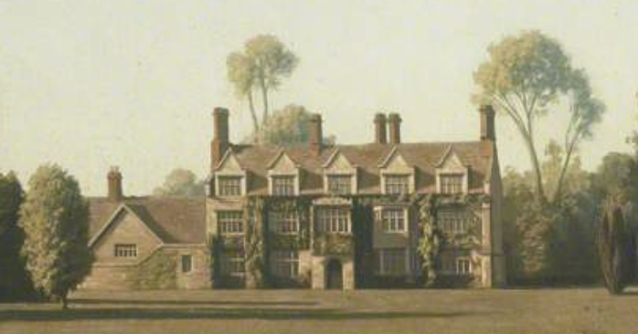

Founded as a hospital during the reign of Henry I and endowed as a priory in 1212. Closed in 1536 during the dissolution of the monasteries, its last private owner was Lord Fairhaven who landscaped the grounds and made extensive additions to the house for his collections. He left the house and contents to the National Trust

illustrated talk by
Helen Ackroyd
Tuesday, 24th September 2024,
7.30 for 8pm
Admission: £3 (members free) refreshments included
Everyone Welcome

